Services

1. Sales & Marketing
Driving business growth through strategic customer acquisition and sales systems.
- Lead Generation Campaigns
- Performance Marketing
- Sales Funnel Development
- Conversion Optimization
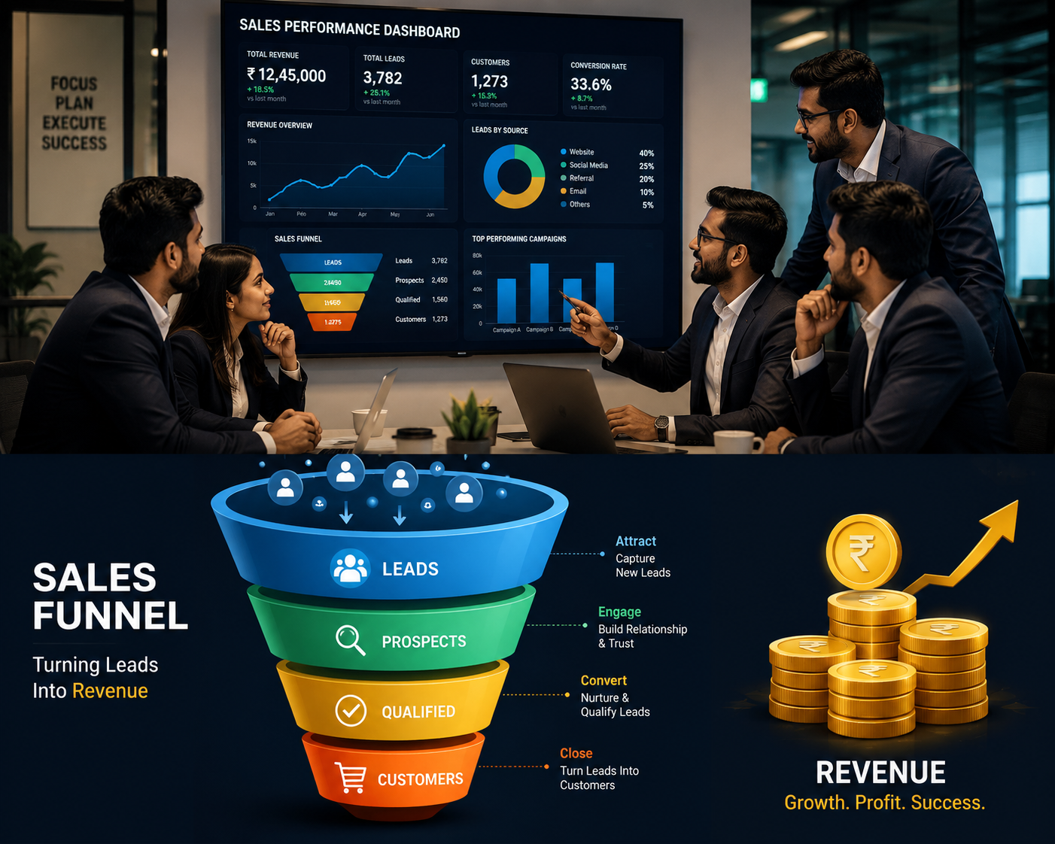

2. Digital Marketing
Helping brands increase visibility, engagement, and online growth.
- Meta & Google Ads Management
- Email & WhatsApp Marketing
- Competitor Analysis & Market Research
- Marketing Analytics & Reporting
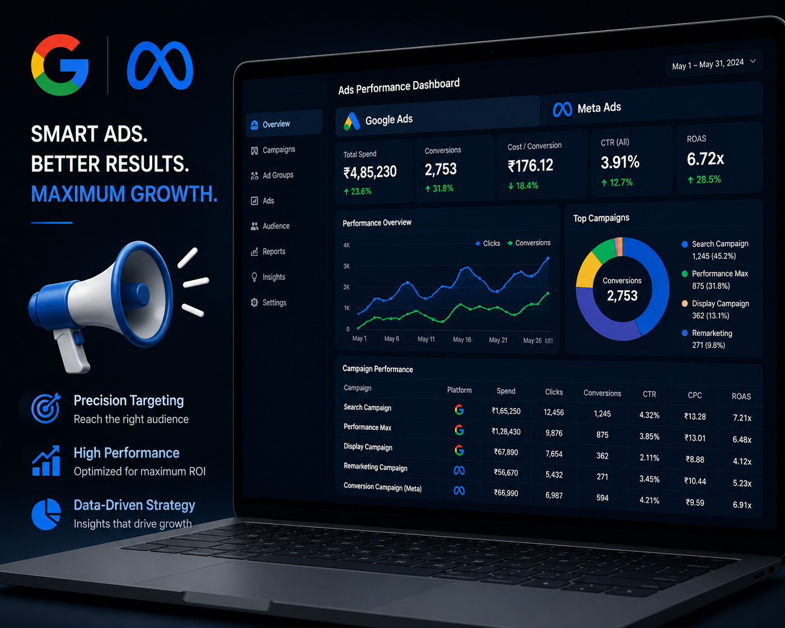

3. Social Media Management & Content Creation
Creating impactful content that drives engagement, authority, and brand awareness.
- Social Media Management
- Reels, Videos & Graphic Design
- Influencer Collaborations
- Podcast Production & Content Strategy
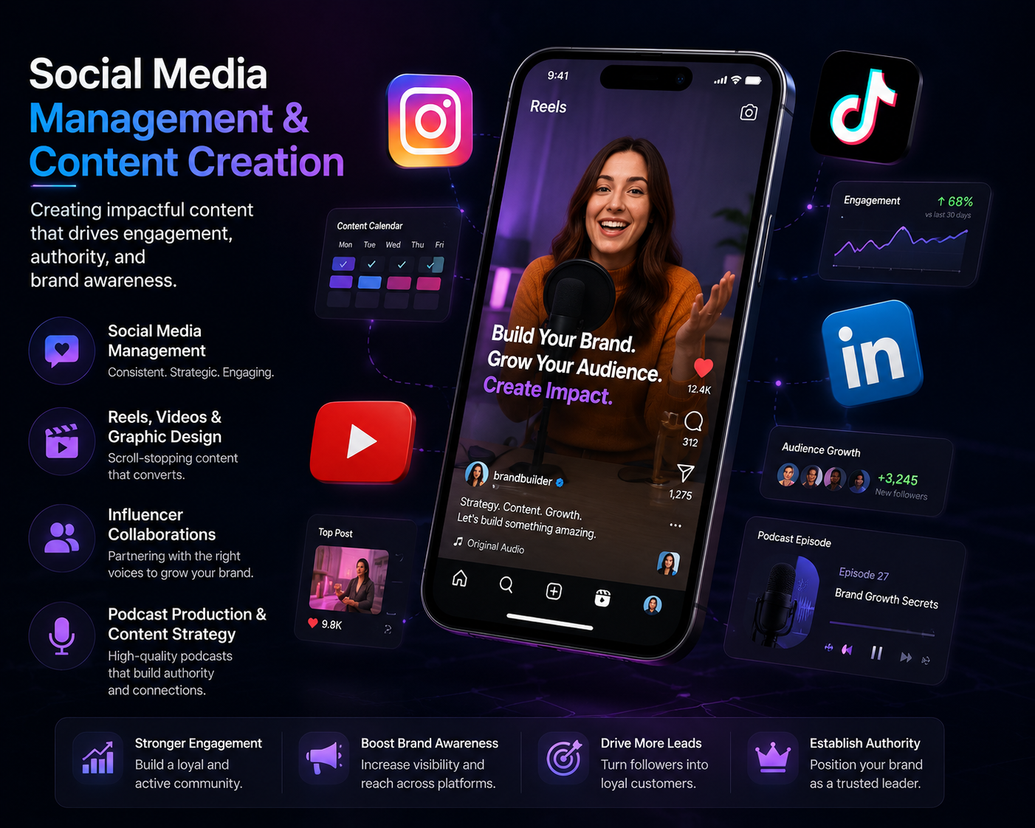

4. AI-Powered Growth & Automation
Streamlining business operations through intelligent technology solutions.
- CRM Implementation
- AI Chatbots & Assistants
- WhatsApp & Workflow Automation
- Sales & Marketing Automation
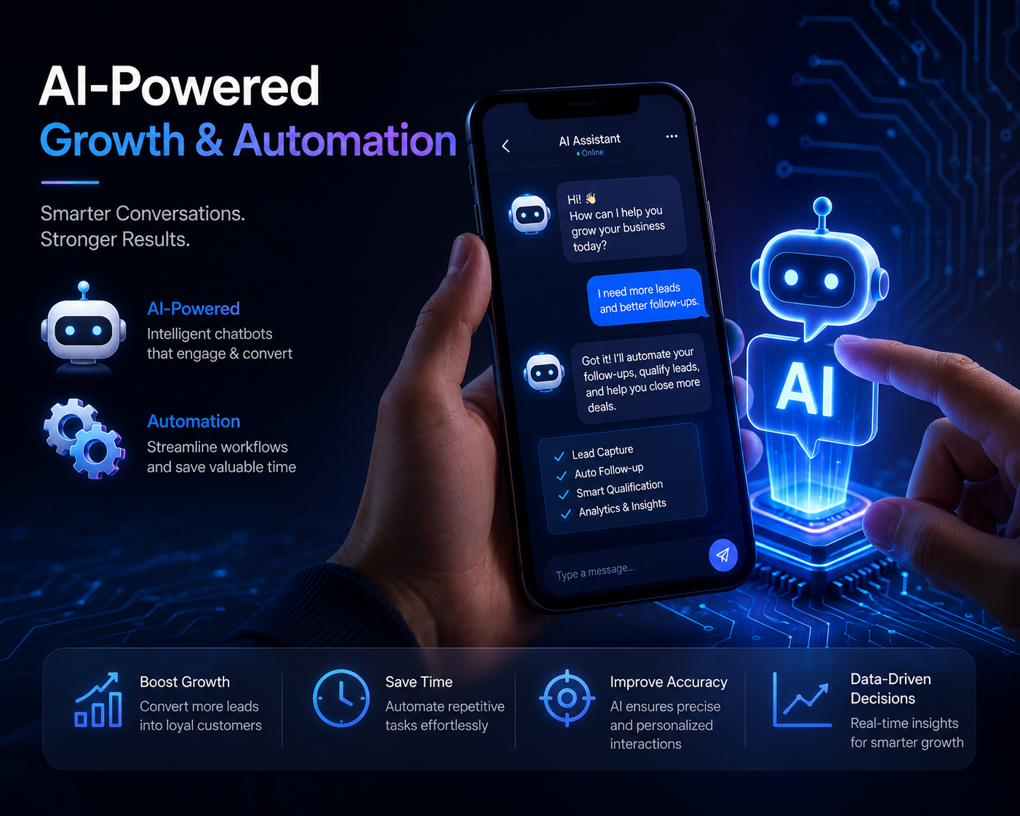

5. Web Development & Digital Infrastructure
Building digital platforms that support business growth and customer acquisition.
- Website Design & Development
- Landing Pages & Business Portals
- E-Commerce Solutions
- Website Maintenance & Support
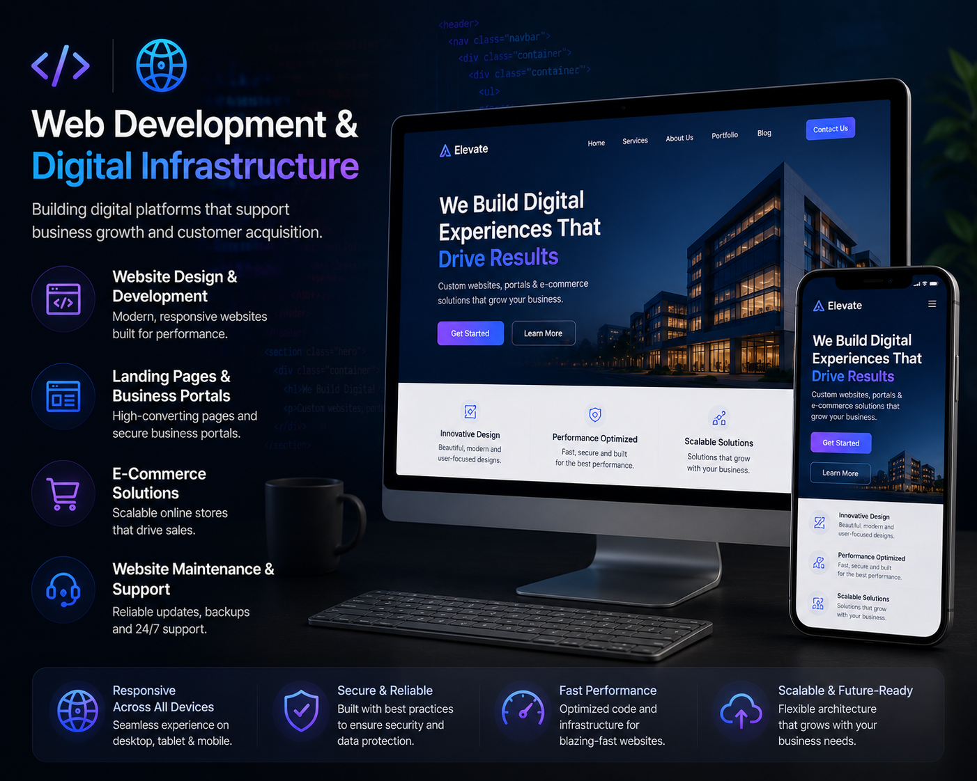

6. Political Strategy & Campaign Management
Delivering end-to-end political consulting and election campaign execution.
- Election Campaign Management
- Public Relations & Media Management
- Voter Survey, Research & Sentiment Analysis
- Narrative Setting & Surrogate Page Management
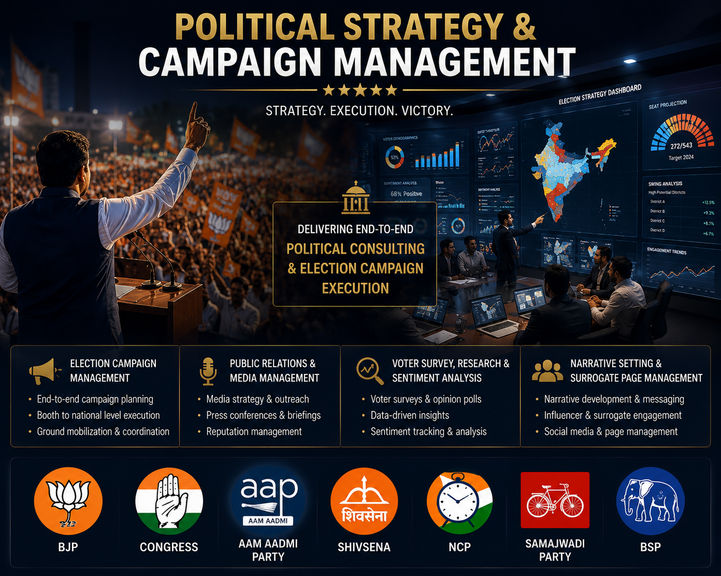

PR | Strategy | Growth

